**Question 1**

Create a table called Employee & execute the following.

**Employee (EMPNO, ENAME, JOB, MANAGER_NO, SAL, COMMISSION)**

* **Create** a user and grant all permissions to the user.
* **Insert** the any three records in the employee table contains attributes

EMPNO, ENAME, JOB, MANAGER_NO, SAL, COMMISSION and use **rollback.**

Check the result.

* Add **primary key constraint** and **not null constraint** to the employee table.
* Insert **null values** to the employee table and verify the result.

**Solution:**

CREATE TABLE Employee (

EMPNO INT,

ENAME VARCHAR (50),

JOB VARCHAR (50),

MANAGER_NO INT,

SAL DECIMAL (10, 2),

COMMISSION DECIMAL (10, 2)

);

DESC Employee;

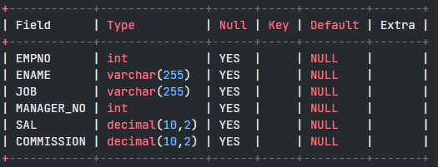

1. Create a user and grant all permissions to the user.

**Query:**

Type these two queries in the current user login:

CREATE USER IF NOT EXISTS 'dbuser1'@'localhost' IDENTIFIED BY ‘dbuser1’;

GRANT ALL PRIVILEGES ON Employee TO 'dbuser1'@'localhost';

Now logout and login with the new username as dbuser1 and password as dbuser1

Employee table should be visible in the new user dbuser1

**2. Insert** the any three records in the employee table contains attributes EMPNO, ENAME, JOB, MANAGER_NO, SAL, COMMISSION and use **rollback.**

**Solution:**

INSERT INTO Employee (EMPNO, ENAME, JOB, MANAGER_NO, SAL, COMMISSION) VALUES (1, 'Kavana Shetty', 'Manager', NULL, 5000.00, 1000.00);

INSERT INTO Employee (EMPNO, ENAME, JOB, MANAGER_NO, SAL, COMMISSION)

VALUES (2, 'Ram Charan', 'Developer', 1, 4000.00, NULL);

INSERT INTO Employee (EMPNO, ENAME, JOB, MANAGER_NO, SAL, COMMISSION)

VALUES (3, 'Honey Singh', 'Salesperson', 2, 3000.00, 500.00);

SELECT * FROM Employee;



**3.** Add **primary key constraint** and **not null constraint** to the employee table.

**Solution:**

Add Primary Key Constraint

ALTER TABLE Employee

ADD CONSTRAINT pk_employee PRIMARY KEY (EMPNO);

Verify primary key constraint

DESC Employee;

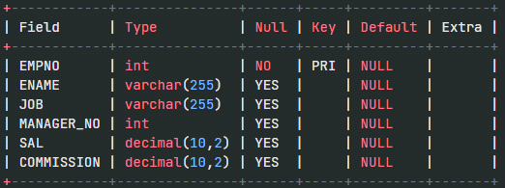

INSERT INTO Employee (EMPNO, ENAME, JOB, MANAGER_NO, SAL, COMMISSION)

VALUES (1, 'Ranjan', 'Manager', NULL, 5000.00, 1000.00);

Duplicate entry '1' for key 'Employee.PRIMARY'

Since EMPNO field is the primary key it cannot have duplicate values, hence we see that the insert operation fails when provided with a duplicate value.

**Add Not Null Constraint**

ALTER TABLE Employee

MODIFY ENAME VARCHAR (255) NOT NULL,

MODIFY JOB VARCHAR (255) NOT NULL,

MODIFY SAL DECIMAL (10, 2) NOT NULL;

INSERT INTO Employee (EMPNO, ENAME, JOB, MANAGER_NO, SAL, COMMISSION)

VALUES (4, 'Ranjan', 'Manager', NULL, 5000.00, 1000.00);

SELECT * FROM Employee;





INSERT INTO Employee (EMPNO, ENAME, JOB, MANAGER_NO, SAL, COMMISSION)

VALUES (7, NULL, 'Tester', NULL, 3500.00, NULL);

ERROR 1048 (23000): Column 'ENAME' cannot be null